Computer Programming  
Lab Tasks



Department of Computer Science - BUIC

Name: Saad Ahmad

Enrollment Number: 01-134222-130

**Exercises/Lab Journal 10**

**Task 1:** Write a program that inputs the names of five countries. It only display the countries whose name starts with vowels.

**Code:**

#include <iostream>

using namespace std;

int main()

{

char country1[20];

char country2[20];

char country3[20];

char country4[20];

char country5[20];

int a = 0;

cout << "Enter the names of five countries" << endl;

cin >> country1 >> country2 >> country3 >> country4 >> country5;

cout << endl;

if (country1[0] == 'a' || country1[0] == 'e' || country1[0] == 'i' || country1[0] == 'o' || country1[0] == 'u'

|| country1[0] == 'A' || country1[0] == 'E' || country1[0] == 'I' || country1[0] == 'O' || country1[0] == 'U') {

cout << country1 << endl;

a++;

}

if (country2[0] == 'a' || country2[0] == 'e' || country2[0] == 'i' || country2[0] == 'o' || country2[0] == 'u'

|| country2[0] == 'A' || country2[0] == 'E' || country2[0] == 'I' || country2[0] == 'O' || country2[0] == 'U') {

cout << country2 << endl;

a++;

}

if (country3[0] == 'a' || country3[0] == 'e' || country3[0] == 'i' || country3[0] == 'o' || country3[0] == 'u'

|| country3[0] == 'A' || country3[0] == 'E' || country3[0] == 'I' || country3[0] == 'O' || country3[0] == 'U') {

cout << country3 << endl;

a++;

}

if (country4[0] == 'a' || country4[0] == 'e' || country4[0] == 'i' || country4[0] == 'o' || country4[0] == 'u'

|| country4[0] == 'A' || country4[0] == 'E' || country4[0] == 'I' || country4[0] == 'O' || country4[0] == 'U') {

cout << country4 << endl;

a++;

}

if (country5[0] == 'a' || country5[0] == 'e' || country5[0] == 'i' || country5[0] == 'o' || country5[0] == 'u'

|| country5[0] == 'A' || country5[0] == 'E' || country5[0] == 'I' || country5[0] == 'O' || country5[0] == 'U') {

cout << country5 << endl;

a++;

}

if (a == 0) {

cout << "No country name starts with a vowel";

}

return 0;

}

**Output:**

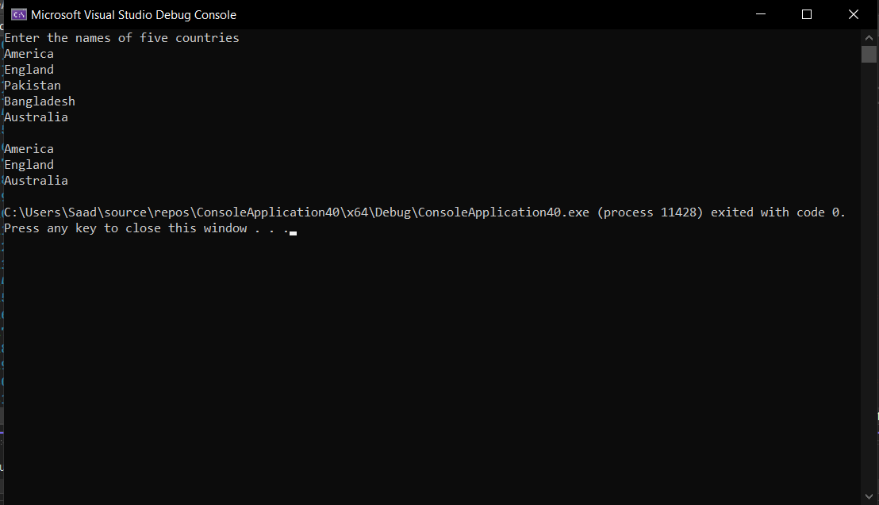

**Task 2:** Write a C++ program that prompts the user to enter a word in a character array and then checks whether it is a palindrome or not. (*NOTE: A palindrome is a word which if reversed, spells the same e.g. RADAR if reversed spells RADAR so it is a palindrome whereas HELLO when reversed is OLLEH which is not a palindrome.)

**Code:**

#include <iostream>

#include <cstring>

using namespace std;

int main()

{

char word[10];

cout << "Enter the word you want check : ";

cin >> word;

int length = strlen(word);

int a = length - 1;

int check = 0;

for (int i = 0; i < length; i++) {

if (word[i] == word[a]) {

check++;

}

a--;

}

if (length == check) {

cout << "This word is a palindrome";

}

else {

cout << "This word is not a palindrome";

}

return 0;

}

**Ouput :**

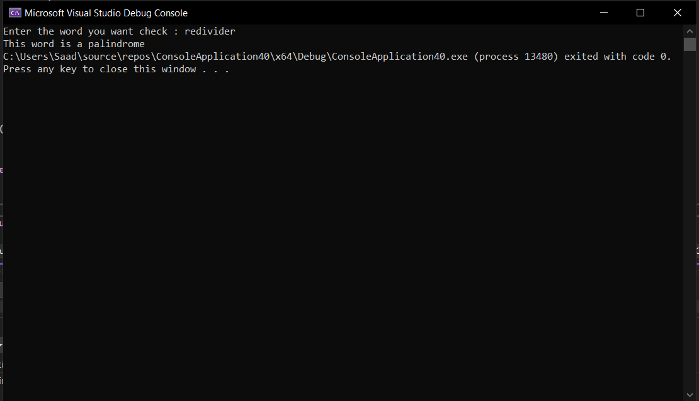

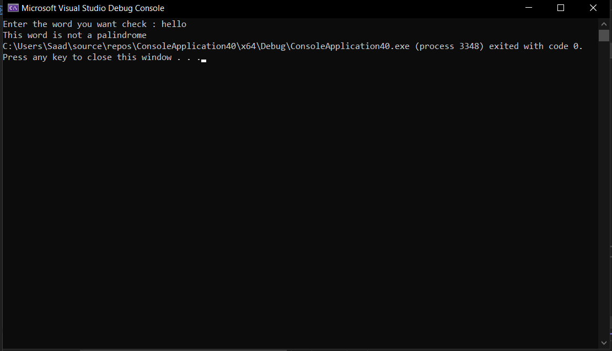

**Task 3:** Write a program that inputs two strings from user and compare them using strcmp function. The program displays whether the first string is less then, equal to or greater than second string.

**Code:**

#include <iostream>

#include <cstring>

using namespace std;

int main() {

char word1[20];

char word2[20];

cout << "Enter string one : ";

cin >> word1;

cout << "Enter string two : ";

cin >> word2;

if (!strcmp(word1, word2)) {

cout << "Strings are equal" << endl;

}

else if (strcmp(word1, word2) > 0) {

cout << "String 1 is greater than String 2";

}

else if (strcmp(word1, word2) < 0) {

cout << "String 2 is greater than String 1";

}

return 0;

}

**Output :**

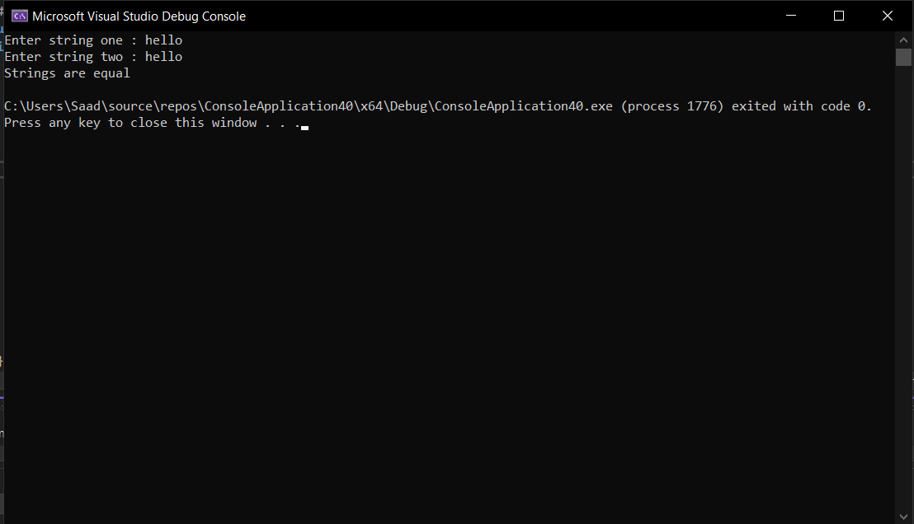

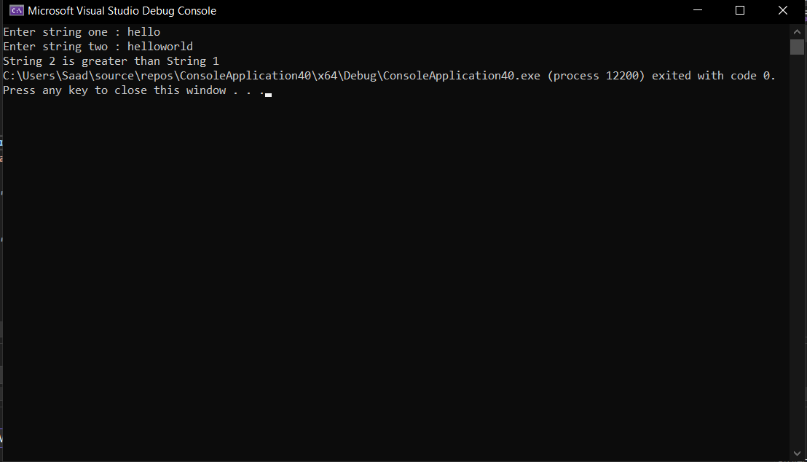

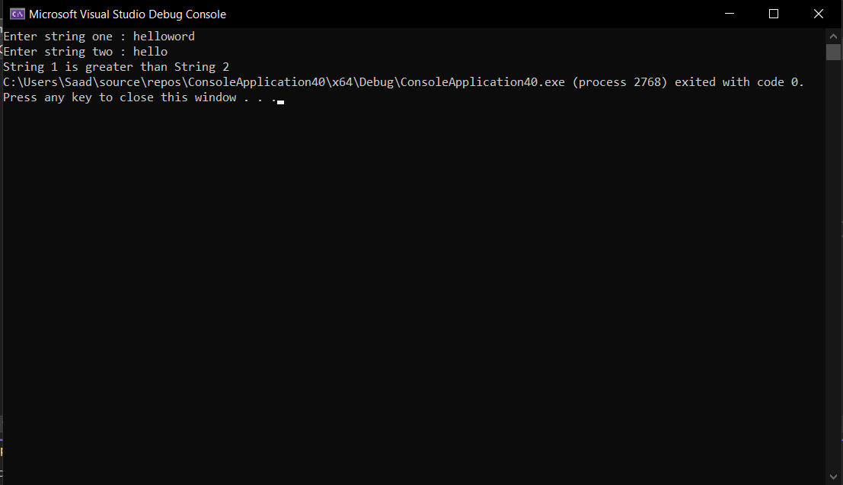

**Task 4:** Write a program that inputs a string and display the number of character in it.

**Code:**

#include <iostream>

#include <string>

using namespace std;

int main() {

string word1;

cout << "Enter a string : ";

getline(cin, word1);

int a = word1.length();

cout << "This string has " << a << " characters";

}

**Output:**

